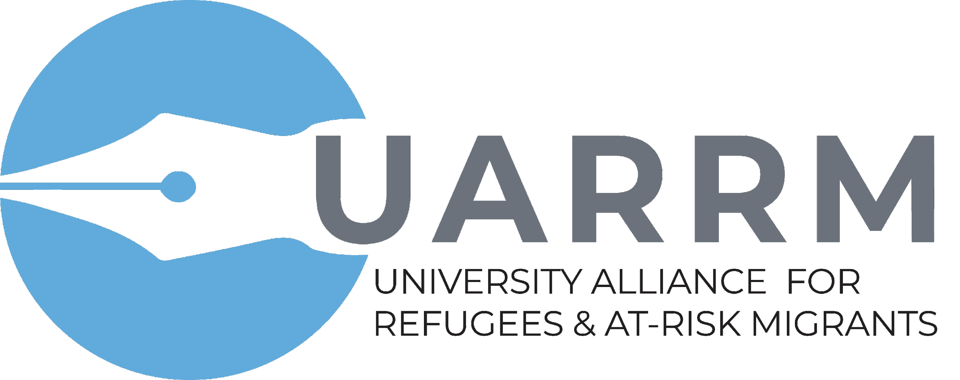

The Second Annual Event of the University
Alliance for Refugees and At-Risk Migrants (UARRM):
Engaging Student Voices to Support the Global Compacts

Friday, November 1, 2019
8:15 am - 4:00 pm

The George Washington University
Cloyd Heck Marvin Center
Continental Ballroom
800 21st St. NW, Washington, D.C.

Students and young people play a critical role in supporting the Global Compacts for Migration and Refugees. How can university and college campuses serve as effective vehicles for student action?

UARRM believes that student voices should be heard. This convening, which marks the Second Annual Event of the University Alliance for Refugees and At-Risk Migrants (UARRM), will open up a space for student leaders to learn from and share their perspectives with higher education leaders, policymakers, and practitioners on a broad range of topics relevant to both Global Compacts.

We anticipate a highly interactive, participatory, and discussion-oriented event. Session 1 will kick off the day with a plenary session (convening up to 125 participants). We will break out into discussion groups during Sessions 2 and 3 (with approximately 30-40 participants in each group). All participants will gather again for the final session to present recommendations.

This event will be co-hosted by No Lost Generation-GWU Chapter, The GWU International Education Program, and Rutgers Graduate School-Newark, with support from the Open Society Foundations and Rutgers Global.

This event is free and open to the public. Meals and materials will be given at this event, so please register in advance.

Event Aims:

- Support student-led efforts to protect and empower at-risk migrants and refugees in university and college communities;
- Strengthen communication between students, higher education leaders, policymakers, and practitioners on intersecting issues of forced migration and higher education;
- Explore how peer-to-peer initiatives in the U.S. and other countries can facilitate educational pathways and opportunities for displaced students;
- Generate a student base dedicated to their own learning and educating the public about issues of forced migration.

Target Participants:

- George Washington University (GWU) and non-GWU students, including those with experiences of displacement and their native-born peers; students with multidisciplinary experiences in the field, as well as those new to these issues who want to learn and get involved!
- Higher education administrators, educators, policymakers, and practitioners in the field who want to share their expertise, but also listen to, connect, and build tangible strategies with and for students around broad intersections of higher education and forced migration.

Program Agenda
8:15 a.m. Registration, Coffee, and Breakfast
Pre-Conference Meet & Greet
Ariel G. Ruiz Soto, Director, Migration Policy Institute (MPI) Internship Program

On Display
ImVisible Newark Highlights

SESSION 1: PLENARY
Continental Ballroom

9:00 a.m. Welcome
Dr. Kyle Farmbry, Professor, School of Public Affairs and Administration,
Rutgers University-Newark
Dr. Bernhard Streitwieser, Assistant Professor, International Education
& International Affairs, The George Washington University (GW)

9:15 a.m. Film Screening
Picturing Malta (Newest Americans-NatGeo Photo Camp Documentary)

9:25 a.m. The Voices of a Global Youth Movement
Emily Parker, Executive Director, No Lost Generation-GW; GW Senior
Hourie Tafech, Co-Founder, Spark 15; Rutgers University PhD Student
Esder Chong, Founder, RU DREAMers; Rutgers University Senior

9:50 a.m. Why is Student Engagement Needed to Support the Global Compacts for
Migration and Refugees?
Dr. Colleen Thouez, Director, Welcoming and Integrated Societies, Open Society
Foundations (OSF)

SESSION 2: SIMULTANEOUS BREAKOUT GROUPS

10:10 a.m. Breakout Group 2A: Supporting Educational Pathways through Peer-to-Peer
Welcoming: Lessons from Canada’s Student Refugee Program (SRP) (Room 311)

Carolyn McKee, Program Officer, Campus Engagement and the Student Refugee
Program at World University Service of Canada (WUSC)
Rhoda Akuol Philip, Former SRP Recipient, University of Toronto
Arianne Leclerc, WUSC Volunteer, Université Laval

Discussion
Moderated by Carolyn McKee

10:10 a.m. Breakout Group 2B: Engaging Higher Education Institutions to Promote
Academic Freedom: Reflections and Recommendations from Scholars at Risk Student Advocacy Seminar Alumni (Room 308)

Dr. Chelsea Blackburn Cohen, Senior Program Officer, North America, Scholars at Risk
Alexandra Bell, Program Assistant, Advocacy, Scholars at Risk
Samuel Finch, Scholars At Risk Student Advocacy Seminar Alumni, Mansfield University
Kyla Yates, Scholars at Risk Student Advocacy Seminar Coordinator, Roger Williams University

Discussion
Moderated by Zerxes Spencer, Director of Fellowship Programs, National
Endowment for Democracy

10:10 a.m. Breakout Group 2C: Bridging Campuses and Local Communities: Sustainable
Models for Student and Institutional Engagement (Room 307)

Dr. Diya Abdo, Founder, Every Campus a Refuge (ECAR); Professor, Guilford
College
Ree Ree Wei, Student and ECAR Volunteer, Guilford College
Nancy Yuan, Student, Swarthmore College, United Nations Major Group for
Children and Youth (UNMGCY)

Discussion
Moderated by Dr. Kathryn Libal, Director, UConn Human Rights Institute

11:40 a.m. Lunch (Continental Ballroom)

SESSION 3: SIMULTANEOUS BREAKOUT GROUPS

12:45 p.m. Breakout Group 3A: Learning to Defend Human Rights at the Border at
Beyond: Lessons from Students and Youth Working on the Ground (Room
307)

Dr. Paulina Vera, Interim Director of the George Washington University Law Immigration Clinic, George Washington University
Evan Hunt, Law Student, George Washington University
Madeleine Delurey, Law Student, George Washington University

Discussion
Moderated by Ian Kysel, Co-founder, International Migrants Bill of Rights
(IMBR)

12:45 p.m. Breakout Group 3B: Accessing and Thriving in Higher Education - Student
Experiences and Perspectives (Room 308)

Lok Darjee, Founder, Project R
Fatou Kinteh, Student, Southwest Minnesota University
Alexandra Croteau, Student, George Washington University

Discussion
Moderated by Dr. Bernhard Streitwieser & Nele Feldmann, Head, IIE Student Emergency Initiatives, Institute of International Education

12:45 p.m. Breakout Group 3C: Multimedia Storytelling and Digital Communications as
a Platform for Student Voices (Room 311)

Johnathan Christie, Student, Rutgers University-Newark
Yeimy Gamez Castillo, Student & Co-Founder, ImVisible
Sara Shah, Student, Rutgers University Newark

Discussion
Moderated by Dr. Tim Raphael, Founder, Newest Americans

2:15 p.m. Break

SESSION 4: PLENARY
Continental Ballroom

2:30 p.m. PLENARY: Debrief and Recommendations

Student and Youth-led Debrief
Hourie Tafech, PhD Student, Rutgers University (2A)
Noor Ghazi, Graduate Student, University of North Carolina (3B)
Esder Chong, Senior, Rutgers University (2C)

Discussion
Moderated by Dr. Miriam Feldblum, Executive Director, Presidents’ Alliance on Higher Education and Immigration

Student and Youth-led Debrief
Aslam Kakar, PhD Student, Rutgers University (2B)
Sara Mora, Student and Undocumented Immigrant Rights Activist (3A)
Krikor Yereztian, IIE Global Education in Emergencies Analyst (3C)

Discussion
Moderated by Jose Magaña-Salgado, Policy & Communications Director, Presidents’ Alliance on Higher Education and Immigration

3:45 p.m. What’s next for the Network?
Dr. Kyle Farmbry and Dr. Colleen Thouez

4:00 p.m. Closing

Contact: info@uarrm.org

About the UARRM
The UARRM is an HEI-led group of researchers, practitioners, policymakers, and students seeking to harness the potential of university and college communities for the empowerment and protection of refugees and at-risk migrants. It is governed by a Steering Committee of senior professionals who are champions in this effort. It functions to raise the visibility of, build partnerships around, and springboard promising university and college-led efforts underway within six specific Action Areas. To learn more visit our website: https://www.uarrm.org/actionareas.

We would like to thank our hosts, No Lost Generation-GW Chapter and the George Washington University International Education Program UNESCO Chair.

